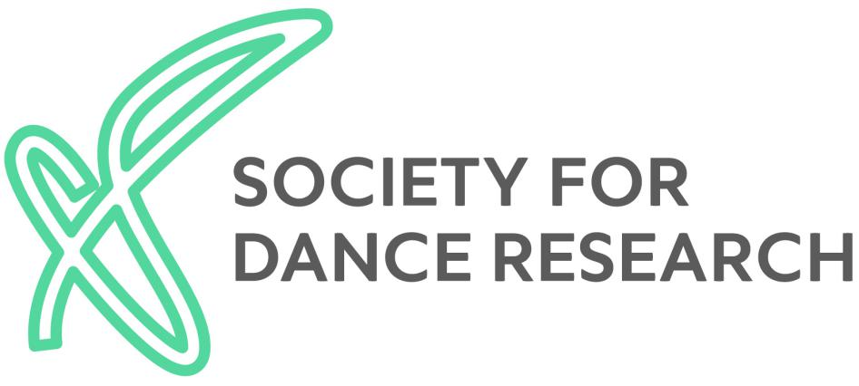

Minutes of the Annual General Meeting held at Rambert, Upper Ground, London SE1 9PP on Saturday 18th January 2020 at 2:00pm

PRESENT: Present: Peter Bassett, Susan Boucher, Amanda Britton, Jane Carr, Fiona Compton,Cristina de Lucas (Treasurer, online), Sinibaldo de Rosa, Bethany Johnstone, Chris Jones, Carole Kew, Lynsey McCulloch, Geraldine Morris, Larraine Nicholas, Deborah Norris, Daniela Perazzo-Domm, Phaedra Petsilas, Kavina Pound, Bethany Pound Green, Stacey Prickett, Jane Pritchard, Maria Salgado Llopis (Secretary), Victoria Thoms, Ella Tighe (online), Lise Uytterhoeven (Chair), Freya Vass-Rhee, Charlotte Waelde (Vice-Chair), Barbara West, Bethany Whiteside (Membership Secretary)

- APOLOGIES FOR ABSENCE: Jeremy Barlow, Alexandra Kolb, Celena Monteiro, Katerina Paramana, Richard Ralph, Laura Robinson, Kathryn Stamp (Newsletter Editor)

- MINUTES from 2018 (held on Friday 26th October 2018 at Sadler’s Wells) were adopted as an accurate record.

  - Chair and Secretary’s report: Lise Uytterhoeven reported on the range of publications, events and initiatives developed in 2019. The Executive Committee (EC) held its third away day in April to revisit the objectives laid down in our constitution and develop strategies for how best to achieve these within the current field of dance research. The new “Ivor Guest Research Grants” (IGRGs), were brought into life in honour of our Founding President and his legacy for the field of dance research with the support of Ann Hutchinson Guest. The 2019 IGRGs were awarded to Anna Kirakowska, Bryony May Kummer-Seddon and Lynsey McCulloch.
In February, the Society joined forces with The British Academy and the V&A in organising a panel discussion and set of performances entitled “Nightlife and Queer Utopias”. The interdisciplinary panel, comprising Ben Campkin, Fenella Hitchcock, Ramón H. Rivera-Servera and facilitated by Flora Pitrolo, discussed the LGBTQ dancefloor as a utopian space to express identities and desires. Hannah Milan and BAM BAM 007 opened the event with a voguing performance and the event closed with a DJ set by Opi Resident DJ of Maricumbia. This collaborative event was attended by approximately 270 people – meaning the venue was at capacity – and attracted the interest of over 3,600 people on social media. Predominantly, these audiences were new to dance research. The British Academy was able to offer BSL interpretation and the Society funded live streaming.
In April, the Society collaborated with the University of Roehampton, which hosted the Research Forum on “Cold War Politics and the Modern Arts, Emerging Approaches and Scholarship”, an initiative by Victoria Phillips. This two-part research forum explored key political perspectives on dance and other modern arts during the Cold War, combining a PhD Student Forum session on methodology and theory in interdisciplinary studies facilitated by Stacey Prickett, Victoria Thoms and Victoria Phillips with talks by invited speakers Jens Richard Giersdorf, Gay Morris and Victoria Phillips. The discussion was live streamed, and a recording made available on the Society’s YouTube channel.
The final event of 2019 was the “Udal: Bodyscape” Choreographic Forum in September, an initiative by Stella Uppal Subbiah from the dance company UYIR. Stella Uppal Subbaiah, with Justin McCarthy and the company, explored the way age, ethnicity and culture inform understandings of Bharatanatyam as a cross-cultural form in a newly choreographed work, set to Tamil Music. Furthermore, Kalakshetra artists K. P. Rakesh and Santhi R. Rajkamal performed “Tamil Boys Don’t Dance”, which explored how many men are afraid to express themselves through dance. The performance was followed by a lively Q&A moderated by Sabine Sörgel, engaging new audiences with the work of the Society.

  - Journal Editor’s report: The report received in advance of the meeting from Richard Ralph, the Journal Editor, included updates on the articles and book reviews contained in the two issues of volume 37.

  - Treasurer’s report: Cristina de Lucas reported on Society finances, which continue to be healthy. She gave an overview of income and expenditure in 2019, and presented a projected budget for 2020. The accounts of the year 2018 were examined by an independent accountant, prior to the submission of our report to the Charity Commission.

  - Membership Secretary: Bethany Whiteside reported that the Society had 102 members of which 76 are based in the UK with over half (35 members) based in London. 41 members renewed for 2020 by direct debit suggesting use of this method is increasing. The decrease compared to the previous year can be explained by the large-scale conference that was held in 2018.

  - Newsletter Editor’s Report: Kathryn Stamp reported that with the introduction of Zoom and Facebook live being used for disseminating society events to a wider audience, it has been necessary to consider how event reports work best for our members. She has investigated the facilities available for report publication on our website, as well as a possible blog feature. Throughout this year she has explored different formats for report writing, engaging with more creative responses to events and innovative ways of presenting this information. Our fantastic Administrator Ella has continued to produce our bi-annual newsletter, which serves as an informative update on current and upcoming events for our members

- Election of Officers and Executive Committee Members: Maria Salgado Llopis reported that Lynsey McCulloch has been elected as Secretary uncontested and Daniela Perazzo Domm as Events Secretary, also uncontested. Jane Carr, Alexandra Kolb, Victoria Phillips, Sinibaldo de Rosa and Charlotte Waelde were elected as Ordinary Members of the Executive Committee. Deborah Norris would be proposed to be co-opted at the next EC meeting.

- Equality, Diversity and Inclusion Policy: The policy was adopted unanimously.

- AOB:
No other business was discussed.

- Lise Uytterhoeven closed the meeting.

Minutes by Lise Uytterhoeven for Honorary Society Secretary Maria Salgado Llopis.

