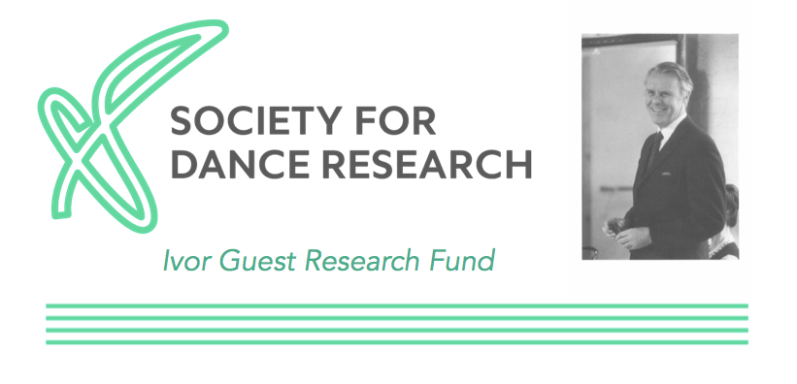

EQUAL OPPORTUNITIES MONITORING FORM
What is your age?
( ) 0 – 19
( ) 20 – 34
( ) 35 – 49
( ) 50 – 64
( ) 65+
( )Prefer not to say

How would you describe your ethnic origin?
These codes have been devised by the Government’s Census of Population and are recommended by the Home Office.
Choose ONE section from A to E, then tick the appropriate box to indicate your cultural background:

SECTION A: WHITE
( ) BRITISH
( ) IRISH
( ) ANY OTHER WHITE BACKGROUND, PLEASE WRITE IN

SECTION B: MIXED
( ) WHITE AND BLACK CARIBBEAN
( ) WHITE AND BLACK AFRICAN
( ) WHITE AND ASIAN
( ) ANY OTHER MIXED BACKGROUND, PLEASE WRITE IN

SECTION C: ASIAN OR ASIAN BRITISH
( ) INDIAN
( ) PAKISTANI
( ) BANGLADESHI
( ) ANY OTHER ASIAN BACKGROUND, PLEASE WRITE IN

SECTION D: BLACK OR BLACK BRITISH
( ) CARIBBEAN
( ) AFRICAN
( ) ANY OTHER BLACK BACKGROUND, PLEASE WRITE IN

SECTION E: CHINESE OR OTHER ETHNIC GROUP
( ) CHINESE
( ) ANY OTHER ETHNIC GROUP, PLEASE WRITE IN

Do you identify as
( ) Female
( ) Male
( ) Transgender
( ) Non-binary
( ) Prefer not to say
( ) Not known
( ) Other; please state _____________________________________________________________________________
Do you consider yourself to have a disability or long term health condition?
( ) Disabled person (including dead or those with long term health conditions, etc)
( ) Neuro Diverse
( ) Learning disabled
( ) Non-disabled
( ) Prefer not to say
( ) Not known
( ) Other

